**AUTOMATED DOOR WITH A MUSIC SYSTEM**

Mohammed Ashfaqul Islam CHOWDHURY 40081235

MD Inan Bin TAHER 40074374

**OVERVIEW**

The project is an AUTOMATED DOOR WITH A MUSIC SYSTEM. The main aim of this project is to automatically open/close the door and play a melodious tune when approached by someone or something. There is no need to open a door manually with a door handle. Moreover, the music system will not play until the person has reached a certain distance, hence making it more efficient as no electrical power would be wasted by playing music for no one at all.

**METHODOLOGY**

1. The HC-SR04 ultrasonic sensor detects the distance between the object (the person) and itself by using the method of echolocation.

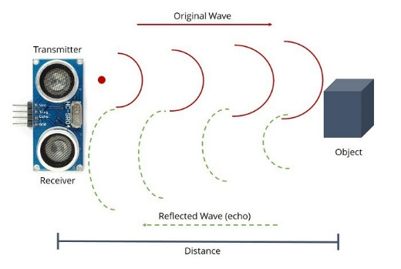

distance = duration * 0.034 / 2

1. As soon as the distance becomes closer than 25 cm, the speaker starts to play a tune and the distance is displayed on the screen. This has been done using the if function.
2. The tone was made using the tone function and notes of different frequencies were defined in the global space. The tone has been set up using arrays. Particular Notes of different frequencies were set in the FREQ array (NOTE_A1, NOTE_B2, NOTE_C3, NOTE_D4, NOTE_C3, NOTE_B2, NOTE_D1, NOTE_C2, NOTE_B3, NOTE_A4). Another array, noteTIME was introduced to determine the duration of each notes and the delays in between.
3. When the distance becomes closer than 15 cm, another if function comes into action. Now, the music stops for a brief period and the door opens automatically by 120 degrees. The new distance is displayed on the screen along with the message “It’s TIME”. Once the door has closed again, the second if function breaks and the music starts to play again until the distance becomes greater than 25 cm again.

**RESULTS**

1. When an object comes closer than 25 cm, a melody starts to play from the speaker. As the objects approaches a distance less than 15 cm, the motor spins 120 degrees and then closes (the delay time can be increased/decreased if required). The door stops rotating if the gap becomes greater than 15cm and the music starts to play once again until the object moves more than 25 cm away from the sensor.
2. A video demonstration has been attached.

**REFERENCES**

1. <http://users.encs.concordia.ca/~bwgordon/arduino_setup.html>
2. <http://users.encs.concordia.ca/~bwgordon/arduino_lab1.html>
3. <http://users.encs.concordia.ca/~bwgordon/arduino_lab2.html>
4. <http://users.encs.concordia.ca/~bwgordon/arduino_lab3.html>
5. <http://users.encs.concordia.ca/~bwgordon/MECH215_lab3_report_format.pdf>
6. <https://randomnerdtutorials.com/complete-guide-for-ultrasonic-sensor-hc-sr04/>
7. <https://www.arduino.cc/reference/en/language/functions/advanced-io/tone/>
8. <https://www.arduino.cc/en/Tutorial/toneMelody>

**APPENDIX**

1. HC-SR04 ultrasonic sensor
2. Ranging Distance: 2cm – 400 cm
3. Measuring Angle: 30 degrees
4. Tower Pro MG90S micro servo
   1. Operating Voltage: 4.8V - 6V
   2. Operating Speed: 0.1s/60 degrees
5. EK1688 2-inch 8-Ohm Audio Speaker Stereo Woofer
6. Arduino_Project_v1_2.ino